Class 1: Introduction and Sources of Law

Risk management
Eg: One of your ex-employees is hoping to join another company. She has asked you to write a reference letter on her behalf. She obviously does not know that you have a very low opinion of her, largely because you believe that she stole money from your business. Furthermore, since the company that she wants to join is one of your best customers, you are tempted to write a candid letter.
Questions for Discussion: Will you write a reference for your ex-employee? If so, what will it say?

→ You need to identify, evaluate, and respond to the legal risks involved.
- Identification: “Can we be held liable for this”
If you accuse your ex-employee of theft, she may sue you for defamation because your statement would cause a reasonable person to think less of her. More surprisingly, if you unreasonably refuse to write a letter, you may be held liable for reducing the ex-employee’s job prospects.
→ In any event, you need to be concerned about liability, about actually being held legally responsible. But you also need to be concerned about the possibility of being sued.

- Evaluation: “What are the changes of sth going wrong?” “What does it cost if it does”
Having identified the risk of being sued for defamation, you may decide that a candid letter would be legally acceptable. Your allegations may be true. Even if they are not, you may be justified in sharing your suspicions with the other company. Furthermore, you may believe that the arguments in your favour are strong enough to discourage your former employee from suing you.

- Response: “What are we going to do about it?”
Finally, having identified and evaluated the risks, you need to formulate a response. You have several options. You can refuse to write a letter. You can write a letter that does not mention your suspicions. Or you can write a letter that accuses your former employee of theft. The choice is still yours. Significantly, however, you are now in a position to make an informed decision. A basic understanding of the law makes you a better business person.

⇒ RISK MANAGEMENT: potential costs associated with nearly every form of behaviour, and that includes doing nothing at all.
- Risk Avoidance: “Eliminate risk”
Eg: An automobile that regularly explodes upon impact should be removed from the market. Aside from issues of morality, the financial costs of being held liable will probably outweigh any sales profits

- Risk Reduction: “Minimize risk”
Eg: a bank that lends $500.000 to a manufacturer realizes that the loan may not be repaid if the economy goes into recession. The bank can, however, protect itself by requiring the business to grant a mortgage over its factory. In that case, if the bank does not get its money, it may at least get the property.

- Risk Shifting: “Make risk someone else’s problem”
Eg: Buy liability insurance for losses caused by danger

- Risk Acceptance: “Live with the risk”
Eg: a golf course that operates behind a factory. It is possible that a wild shot might
hit a factory window, and that the golf course might be held responsible for the resulting damage. Nevertheless, if the likelihood of such an accident is small, the club might decide to do nothing at all. It certainly would not close the course to avoid the risk altogether. It might also find that the costs of reducing the risk by erecting a large safety net, or shifting the risk by buying an insurance policy, are too high. The most sensible approach might be to hope for the best and pay for any windows that are broken.

A Map Of The Law
- Civil Law jurisdiction: Originated in ancient Rome
- Common Law jurisdiction(*): Originated in England

Public Law and Private Law
- Public Law: concerned with governments and the ways in which they deal with their citizens, includes:
- Constitutional law: provides the basic rules of our political and legal systems, determines who is entitled to create and enforce laws, and it establishes the fundamental rights and freedoms that Canadians enjoy.

- Administrative law: concerned with the creation and operation of administrative agencies, boards, commissions, and tribunals.

- Criminal law: deals with offences against the state = concerned with people who break rules that are designed to protect society as a whole.

- Tax law: concerned with the rules that are used to collect money for public spending.
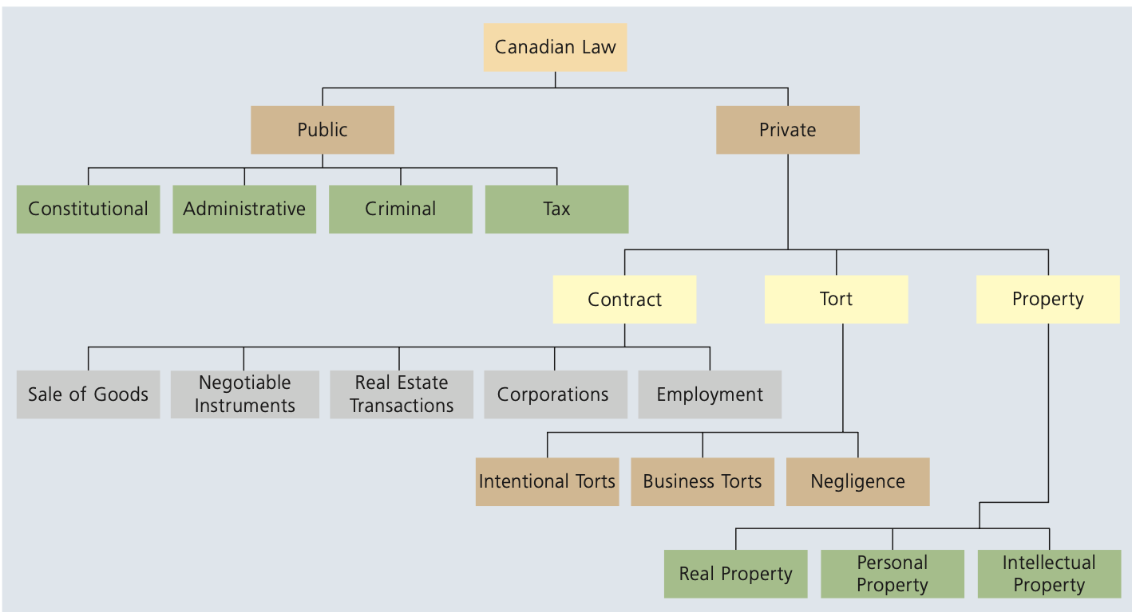

- Private Law: concerned with the rules that apply in private matters. Both parties in a private dispute are usually private persons, either individuals or organizations such as corporations, usually divided into three main parts:
- The law of torts: a private wrong, an offence against a particular person, divided into:
- Intentional torts: such as assault and false imprisonment
- Business torts: such as deceit and conspiracy
- Negligence: which covers most situations in which one person carelessly hurts another

- The law of contracts: concerned with the creation and enforcement of agreements

- The law of property: concerned with the acquisition, use, and disposition of property

(*) Criminal (Case brought by the state (Crown)) vs Tort (Case brought by the individual victim):
Eg 1: At a bar in Toronto, Liam throws a bottle at Noah during an argument. Noah suffers a broken nose.
- Criminal law: The Crown can charge Liam with assault causing bodily harm. Even if Noah doesn’t want to proceed, the state can continue prosecution.
- Tort law: Noah can sue Liam for battery and claim damages for: Medical expenses, Lost wages, Pain and suffering

Eg 2: Emma drives drunk and crashes into Olivia’s car. Olivia suffers a spinal injury.
- Criminal law: The Crown charges Emma with impaired driving and dangerous driving causing bodily harm.
- Tort law: Olivia sues Emma for negligence and seeks compensation for: Medical treatment, Rehabilitation costs, Loss of future income

Sources of Law
(3 sources)
- The Constitution: most important, creates the basic rules for Canadian society, including its political and legal systems.
- Every other law in the country must be compatible with it: Section 52 of The Constitution states, “any law that is inconsistent with the provisions of the Constitution is, to the extent of the inconsistency, of no force or effect.”
- Very difficult to change: Requires consent of both Parliament and Legislatures of two-thirds of all provinces with at least 50% of population (for anything affecting multiple provinces)
- Division of power:
- Federal:
- Governs the country as a whole.
- Has the residual power (that gives the federal government authority over everything that is not specifically mentioned)
- Provincial and Territorial:
- Manage local matters and regional interests.
(*) Can only act within their powers, or law is ultra vires and unconstitutional.
Eg: The federal government passed a law banning the importation and manufacture of margarine to protect the dairy industry. The Supreme Court of Canada ruled the law was partially invalid.
- Valid: Federal government can ban importation of margarine → falls under its power over international and interprovincial trade.
- Invalid: Federal government cannot ban manufacturing of margarine → production within a province falls under provincial authority over “property and civil rights.”
⇒ Federal government controls trade between provinces and countries.
Provinces control production and sale within their own borders.

- Taxation Power & The Constitution
- Rule: The Constitution limits how governments get money.
- Federal Power: Unlimited. Can use any tax system.
- Provincial Power: Limited to Direct Taxes only (taxpayer pays it themselves).
→ The Conflict: Provinces often try to create taxes that "look" direct but are actually indirect (passed to customers). If a court finds a provincial tax is indirect, it is struck down as unconstitutional.

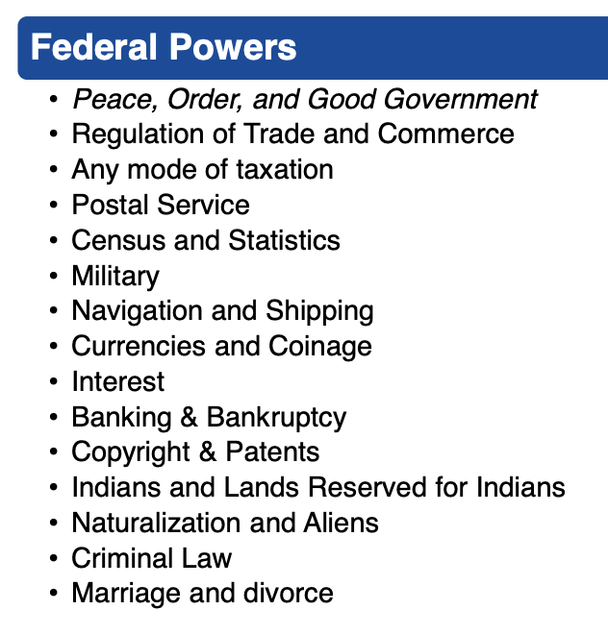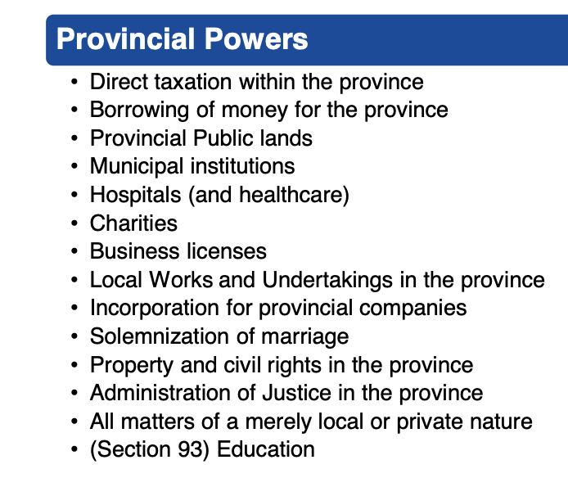222
- Legislation
- The courts

5. Charter of Rights and Freedom
Eg: Quebec passed a law banning most commercial advertising directed at children under 13. Irwin Toy wanted to advertise toys on television and challenged the law.
→ It argued the law was unconstitutional because:
- It regulated television, which is a federal matter.
- It violated freedom of expression under s. 2(b) of the Charter.
- Division of Powers Issue
- The Supreme Court of Canada agreed that telecommunications (including broadcasting) fall under federal jurisdiction.
- However, the Quebec law was not really about regulating broadcasters. Its main purpose was to regulate advertisers, which falls under provincial power over property and civil rights.
⇒ Result: The law was valid under the division of powers because its effect on television was only incidental.
- Charter (Freedom of Expression) Issue
- The Court said advertising is a protected expression under s. 2(b).
- Therefore, the ban did infringe freedom of expression.
Under s. 1 of the Charter, rights can be limited if the limit is reasonable and justified in a free and democratic society.
⇒ The Court held the law was justified because:
- Protecting children from commercial exploitation is an important objective.
- The ban was carefully tailored (applied only to children under 13).

Class 2 Tort

